Modeling Patterns in Nature

Final Report

By: Blake Holland, Theodore Jagodits,

Isabelle Rivera, Christopher Rudel

May 18th, 2020

EN 250: Quantitative Biology

*I pledge my honor that I have abided by the Stevens Honor System.*

Modeling Patterns in Nature

(Note: “The harmony of the world is made manifest in Form and Number, and the heart and soul and all the poetry of Natural Philosophy are embodied in the concept of mathematical beauty.” D'Arcy Wentworth Thompson)

**Table of Contents**

1. History
2. Definition ……………………………………………………………….2
3. Example in Nature ……………………………………………………….2
4. Previous Studies …………………………………………………....3
5. Derivation
6. Sacred Geometry ……………………………………………………...4
7. Minimal Surface ………………………………………………………..4
8. The Spiral ……………………………………………………………….6
9. Morphogenesis ………………………………………………………...7
10. Application
11. Art ………………………………………………………………………..8
12. Pattern Language ……………………………………………………………….8
13. Organization …………………………………………………………..9
14. Research on Disease Spread
15. Model ………………………………………………………………………..8
16. Variables & Assumptions ………………………………………………………….8
17. Integration …………………………………………………………..9
18. Result & Analysis …………………………………………………………..9
19. Conclusion ………………………………………………………………..9
20. References …………………………………………………………...10
21. History
22. Definition

Patterns in nature have been observed since the time of Early Greek philosophers and have continued to advance a number of our disciplines dozens of times over. No matter where you look, nature has instilled mathematical techniques for the sake of maximum efficiency and balance, demonstrating nature’s unparalleled mastery over numbers. Much like *The Matrix,* the universe is an infinite accumulation of code, its language, numbers and shapes, governing organization and efficiency of life. Animals, including ourselves, utilize these techniques in a way that benefits us, most of the time without us evening knowing. The patterns we have identified are used and incorporated in our art, infrastructure and engineering, as well as our research.

1. Examples in Nature

There are many examples in nature that you are already aware of and may not yet know what significance they hold. One of the most prominent patterns in our culture is music. Pythagoras was the first to hypothesize the relationship between mathematics and music, noting that there are ratios governing the pitch of sounds, namingly what we call harmonic series (Stewart). If you play an open string on a stringed instrument and then play the same string but half its length you will hear the same note but in a different octave: the series of eight notes occupying the interval between (and including) two notes, one having twice or half the frequency of vibration of the other. Everytime you turn on the radio you are quite literally listening to a flow of patterns and numbers, making music one of the most observed patterns of nature in our own culture.

Then, there's the beauty of the honeycomb, the poster child of the power of patterns. Honeybees design their hives in a way that maximizes space for the storage of honey and larva. In 1999, Professor Thomas Hales proved the Hexagon Honeycomb Conjecture, which states that regular hexagons provide the least-perimeter way to enclose infinitely many unit areas in a plane (Morgan). Because it takes almost twice as much energy to produce beeswax than honey, honeybees have derived a way to store their honey in a way that maximizes the most space without compromising energy.

1. Previous Studies

As mentioned previously, Pythagoras pondered the presence of patterns in music, performing simple experiments to confirm his suspicions. It is said this curiosity was originally sparked by the sound of a blacksmith's anvil. With each swing the anvils were consistent in the sound they produced and the different sized anvils produced a pitch of sound that seemed to correspond with the size ratio of the anvil being swung. Greek philosophers Plato and Empedocles studied patterns as well, trying to explain order in nature. It wasn’t until scientists such as Charles Darwin’s and his theories of evolution and natural selection circulated in the science community that the understanding of visible patterns started to gain significance.

Physicist Joseph Plateau studied soap films and eventually came up with the concept of minimal surface. Plateau formulated a mathematical concept, Plateau’s Law, that describes the structures formed by films in foams. The biologist Ernest Haeckel “painted hundreds of marine organisms to emphasise their symmetry” (Patterns in Nature). D’Arcy Thompson, Alan Turing, and the dynamic duo Aristid Lindenmayer and Benoȋt Mandelbrot each discovered some of the most known and prominent patterns in nature such as spirals, morphogenesis (spots and stripes), and fractals respectively.

Spirals are prominent among plants and animals as well as a lot of our current cultural artists. From a physics perspective, leaves will grow in a spiral formation because it is the lowest energy configuration and from a biological perspective, leaves are more likely to receive the maximum amount of sunlight in this configuration. There is a unique spiral pattern found in nature that follows a sequence such that each number is the sum of the two preceding ones. You might have recalled this to be the Fibonacci sequence. Many flowers, including sunflowers, utilize this sequence for low energy configurations.

“Fractals are infinitely self-similar, iterated mathematical constructs having fractal dimensions” (Patterns in Nature). Fractals can be found in plants such as ferns, clouds, snowflakes, and lightning. They are patterns that repeat themselves over time and become complex at larger scales. Because things in nature aren’t innately infinite they are usually found in an order of one, two, three or four. However, recently with computer aided technology we are able to produce fractals that seem to have an infinite lifespan.

B. Derivation

1. Sacred Geometry

Most of the patterns already mentioned, as well as many more found throughout nature, follow one proportion or function, thus creating a pattern we can interpret. Scientists call these Golden Numbers, Angles, or Proportions signifying their near perfection. Most of these Golden entities are governed by geometrical relations and physical geometrical shapes. Philosophers realized the importance of geometry and its role in nature noting prevalent and reoccuring geometrical shapes. This study of patterns, shapes, and ratios created a new school of thought called Sacred Geometry (Carlson).

Sacred Geometry has religious and spiritual significance. Buddhists, Egyptians, and Romans have incorporated the power of geometry in their scriptures and dwellings of the house of their respective deities. A majority of these enthusiasts believe that these shapes were derived from God himself, for who else is capable of such beauty and perfection?

1. Minimal Surface

Joseph Plateau is considered the first person to considerably and specifically experiment and inquire on the properties of surface tension. He performed two experiments that were undeniably distinct in procedure, however, similar in the outcome they produced (*Joseph Plateau*). For one, he used a drop of oil which he submerged in a fluid combination of water and soap. Submerged in the fluid, the drop of oil takes on a spherical shape. However, upon spinning, the drop begins to flatten at the “poles” of the sphere and if the speed were increased, it continues to flatten, taking on the shape of a torus.



In the second experiment Joseph takes two wires of circular nature and dips them in soap to create the attractive illusion one might see in Central Park. He then pulled apart the wires and created a soap bubble whose properties he was interested in. The further the wires distanced from each other the more the soap bubble began to collapse in the middle, eventually, taking on the shape of an unduloid.

Both of these experiments are later compared to the structure and mannerisms of cells and single-celled organisms. D’Arcy Thompson came to this conclusion and eventually elaborated on it in the *Forms of Cells,* chapter four in his book On *Growth and Form and Geometry*. Since then it has been debated whether Geometry has a direct correspondence to cellular structure or whether it is encoded in the genome. Recently, “A paper by Terasaki...breathe[d] new life into the old dream of mathematical biology by discovering that the connections between endoplasmic reticulum (ER) sheets mimic a well-known class of mathematical surfaces and that this shape is in fact predictable from simple physical rules governing membrane energetics” (Marshall).

Plateau’s experiments also sparked a number of mathematical theories that have now been labeled “Plateau’s Problems.” Plateau’s Problem encompasses an array of mathematical problems that deal with an element present across a surface and constrained by a boundary. Many that have been solved today include Riemann's theory of minimal surfaces, the Douglas-Plateau Problem on Immersion of Discs and Surfaces, and Flemings Orientable Generalized Surfaces. All of these conjectures have resulted in commonly used mathematical equations that are used in calculus (Harrison).

1. Minimal Surfaces div
2. Hausdorff Measure

Plateau’s Problems continue to produce mathematical inspiration due to its hidden depth and continues to advance mathematics beyond what it is now.

1. The Spiral

The spiral pattern occurs naturally in nature, such as plants, animals, humans, and galaxies. One of the most important scientists who studied spirals is Leonardo of Pisa, better known as Fibonacci. Fibonacci was born around the 13th century and traveled a great deal of the western hemisphere where he picked up Hinudu-Ariabic mathematics. Upon returning to Europe, Fibonacci was determined to share the knowledge of the mathematical system and integrate it into Europe's economic and financial system.

Later, using these mathematical techniques, Fibonacci created the Fibonacci sequence. Fibonacci used a hypothetical situation involving “the hypothetical population of rabbits based on idealized assumptions” (Leonardo Fiboancchi – Italian Mathematician). He hypothesized that after each generation the number of pairs of rabbits would follow the sequence that progressed by adding the two previous terms starting at one. Many of the implications of this discovery were not known until well after Fibonacci's death. It is known that many species of plants utilize this sequence during their growth, due to the near perfect spacing and organization it provides.

Since its discovery, the Fibonacci Sequence has been studied by a number of scientists including Robert Simson, the inventor of the Golden Ratio. Simson found that the ratio between two adjacent terms in the Fibonacci sequence, especially those of a higher order, approached 1:1.6180339887. This ratio can be found throughout nature including that of our own culture. Egyptians and Greeks followed the pattern of a rectangle whose sides were defined by the Golden Ratio.

1. Fibonacci Sequence 0, 1, 1, 2, 3, 5, 8, 13, 21...

Another important aspect of the spiral are fractals: “mathematical phenomena that display a constantly repeating pattern on every scale” (Research and Reflection: Fractals, the Fibonacci Spiral, and Nature). The Fibonacci Sequence is a unique fractal in that it forms an infinite set of predictable patterns. However, fractals are infinitely more complex in that their patterns can be chaotic and unpredictable as long as they follow an unforeseen and infinitely generated pattern. Prominent examples of fractals in nature include: the nautilus, pineapple, flower petals, the growth pattern in trees.

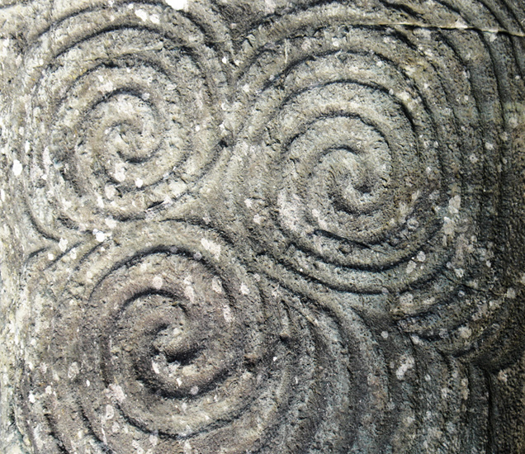

(Early Cave Paintings of Spirals)

http://www.bradshawfoundation.com/ancient_symbols_in_rock_art/ancient_symbols_in_rock_art.php

1. Morphogenesis

If someone were asked to give examples of patterns found in nature one of them would most likely be the stripes of a zebra or the spots of a leopard. These patterns are part of a phenomena called morphogenesis. Alan Turing proposed theories of morphogenesis in his paper *The Chemical Basis of Morphogenesis* through a process called intercellular reaction-diffusion. He theorized that reactions are either inhibited or excited which are influenced by outside sources, eventually creating a pattern. Some organisms have genes called morphogens, which can be activated by a chemical signal, that are dispersed throughout the body in a way that creates patterns. Lets say these morphogens were situated throughout the body in clumps and were activated by a chemical signal. This particular pattern produces spots.

Turing's research has had lasting impact on the understanding of patterns produced by biological systems. His research is being used across a broad range of biological disciplines and can be seen in research such as prosthetics.

C. Application

1. Art

For many centuries, artists from many cultures have embedded fractal patterns. The reason why so many artists use patterns in their art is because it makes them so appealing. Research has shown that works of art that contain patterns are visually appealing and stress-relieving (Florence 1). Jackson Pollock is a famous American painter from the late 1940s whose art has been studied among many scientists. Pollock’s famous poured paintings may look like splattered paint at first glance, but research has shown that his paintings actually display fractals from nature. Scientists who have studied the fractal patterns in Pollock’s paintings are able to analyze and identify if a painting was or was not created by Pollock (Ouellette 1).

Another famous pattern found in art and even in architecture is the golden ratio. The golden ratio can be found in ancient and medieval architecture such as the Great Pyramid of Giza, the Parthenon, the Great Mosque of Kairouan, and the Notre Dame de Paris. As for art, Leonardo DaVinci often incorporated the golden ratio, also known as the divine portion, in his artwork. It is widely believed among artists that the golden ratio can make beautiful shapes, which is why it is commonly found in art. DaVinci embedded the golden ratio in his most famous works of art such as the Mona Lisa, the Last Supper, and the Vitruvian Man (Museum of Science).

1. Pattern Language

Every organism on the entire planet utilizes some form of language to interact with their environment. A great deal of this language can be considered abstract as in the body's chemical or physical response to outside stimuli, however, this section aims towards a higher level of communication, one that is conscious and most likely used when using communicating with other organisms, especially those of their own kind. Within these languages, especially our own, there are recurring patterns.

Christopher Alexander created a concept of organization called Pattern Language, which aims to be “simple, conveniently formatted, humanist solutions to complex design problems ranging in scale from urban planning through to interior design.” (Dawes). Alexander acknowledges that this concept existed before acknowledging it. Humans and animals alike have compartmentalized actions and ways of thinking that are suited for specific tasks. It provides for easy understanding as well as easy transmission to later generations. This concept can be seen in our education system, government, and day to day activities.

However, Alexander utilizes the term on a more specific level, encouraging professions to break down their activities into groups for easier comprehension and understanding.

1. Organization

Our society has copied basic patterns in nature for simple organization on small and grand scales. The pyramids were built according to symmetry adding to their beauty and structural integrity. Cathedrals have been built according to natural and recurring numbers to add beauty, helping bolster their religious authority.

Patterns have also been used in interior design and architecture to provide pleasing effects. Richard Taylor explains that patterns provide a stress-reducing effect on the human brain due to studies revealing the brain's powerful ability for pattern recognition (*Patterns in Nature: Why We Need Them in the Built Environment*). Many of the most famous architects almost always incorporate patterns in their creations.

D. Research on the Spread of Disease

1. Model

The model consists of a matrix of people that move and interact with each other. A certain percentage of the population starts off infected and the people can move around and interact with each other within a certain time step. This cannot be confused with a day. After every time step, the progress of each person is measured with a census. We can track the disease spread with the number of people. The person can have a higher chance of being infected if there are more people surrounding the person and social distancing removes people from each other so that they cannot infect each other.

Older people have a higher chance of dying compared to younger people. This reflects a recent study in New York.

1. Variables and Assumptions

Age - Age randomly determined at the start of the model evenly distributed

Social Distancing - Whether the person is social distancing or not.

Location - Location of the person inside the matrix

Sick - If a person is sick or not

Sick Days - How many days the person is sick

Initial Sick Population percentage - randomly determined if person gets infected at the start

Population density - percentage how densely populated the matrix is

Assumptions:

Nobody dies during the simulation.

Age is evenly distributed among the population(not true real world)

People can be reinfected.

1. Integration

Matrix Creation

We have already described how we created a matrix. At the beginning the matrix is filled by the population density variable. A point is randomly chosen between 0 and 1, and if it is below the population density, a person is created. This continues through the entire matrix row by column. When the person is created, a random variable also between 0 and 1 that determines if the person is sick or not. Also we randomly pick a number in between 1 and 100.

Time Step

Every time step the people have a chance to move around in a random direction on the matrix. If they are in proximity of each other there is a chance of infection, the more infected people around the chance of being infected is multiplied. The ages matter when you get sick. The age groups are in sets of ten [0-10, 11-20, … etc.]. The older a person is, the higher chance of death during being sick.

1. Results and Analysis -

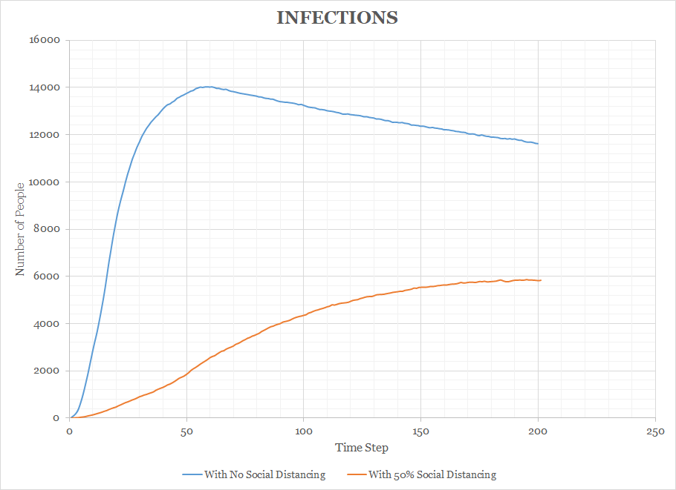

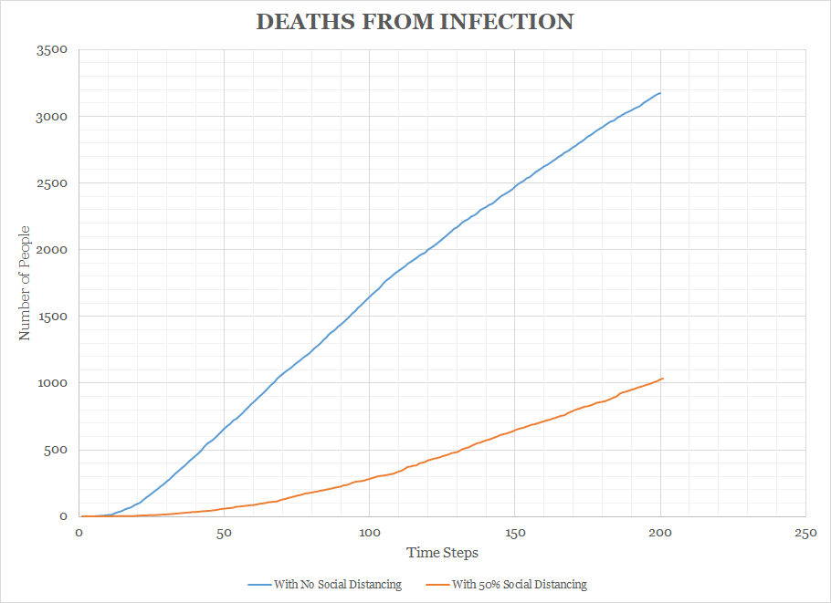

Results

The infection rate for no social distancing is five times higher than the 50% social distancing. The death rate is also ten times higher. The graph is also heavily skewed to the left in both cases, however the peak is much lower for the social distancing case.

Analysis

We can conclude that social distancing does flatten the curve, not only that it also decreases death rates even when 50% participate. With people having the chance of being reinfected. The infection rate does not drop off very quickly as the population gets reinfected. As this is a study of CoVid-19. We are still looking into if people can get reinfected. If they can, the population will

E. Conclusion

Nature in all of its chaos is surprisingly mathematical in various surprising aspects. The explanations for the intricacies in the various patterns visible to us are discrete and sometimes only hypothetical. Many patterns occur due to their efficiency, such as honeycombs or the structures of various plants; however, some plants that exhibit fractal like structures do so for unknown reasons. Humans have drawn on various pleasing aspects of these patterns to create various pleasing structures and architectural works. These recognizable patterns are the foundation for our brains, artistic works, architectural designs, and societies.

F. References

Carlson, R. “The Meaning of Sacred Geometry.” *Sacred Geometry International*, 14 May 2019, sacredgeometryinternational.com/the-meaning-of-sacred-geometry/.

Dawes, M.J., Ostwald, M.J. “Christopher Alexander’s A Pattern Language: analysing, mapping and classifying the critical response.” *City Territ Archit* (2017), https://doi.org/10.1186/s40410-017-0073-1

Florence Williams, Aeon. “Why Fractals Are So Soothing.” *The*

*Atlantic*, Atlantic Media Company, 26 Jan. 2017,

www.theatlantic.com/science/archive/2017/01/why-fractals-are-so-soothing/514520/.

Harrison, J., “Plateau’s Problems: What’s Next.” University of California, Berkeley. 2016.

“Leonardo Fiboancchi – Italian Mathematician (Wrote Leber Abaci).” *The Story of Mathematics*, www.storyofmathematics.com/medieval_fibonacci.html.

Marshall, W., “Differential Geometry Meets the Cell.” *Cell*. July 18, 2013, https://doi.org/10.1016/j.cell.2013.06.032.

Morgan, F. “Frank Morgan's Math Chat - HALES PROVES HEXAGONAL HONEYCOMB CONJECTURE.” *Mathematical Association of America*, 1999. www.maa.org/frank-morgans-math-chat-hales-proves-hexagonal-honeycomb-conjecture.

Museum of Science. “Activity: Golden Ratio.” Leonardo Da Vinci - The

Genius, www.mos.org/leonardo/activities/golden-ratio.

Ouellette, Jennifer. “Pollock's Fractals.” *Discover Magazine*, Discover

Magazine, 21 May 2019.

“Patterns in Nature.” *Wikipedia*, Wikimedia Foundation, en.wikipedia.org/wiki/Patterns_in_nature?oldid=626975484.

“Patterns in Nature: Why We Need Them in the Built Environment.” TerraMai, 26 Oct. 2018, www.terramai.com/blog/patterns-in-nature-and-built-environment/. Accessed 12 Mar. 2020.

“Research and Reflection: Fractals, the Fibonacci Spiral, and Nature.” *Fibonacci Reflection*, https://blogs.uoregon.edu/mjanesaad199/scientific-research-fractals-the-fibonacci-spiral-and-nature/.

Stewart, James. “Timeline 002: Pythagoras And The Connection Between Music And Math.” *Vermont Public Radio*, www.vpr.org/post/timeline-002-pythagoras-and-connection-between-music-and-math#stream/0.

*Turing, A. M., “The Chemical Basis of Morphogenesis.” Philosophical Transactions of the Royal Society of London. Series B, Biological Sciences*, Vol. 237, No. 641. (Aug. 14, 1952), pp. 37-72.